=====================================

Model for nu=0.001

Model: "sequential"

_________________________________________________________________

Layer (type) Output Shape Param #

=================================================================

dense (Dense) (None, 20) 60

dense_1 (Dense) (None, 20) 420

dense_2 (Dense) (None, 20) 420

dense_3 (Dense) (None, 20) 420

dense_4 (Dense) (None, 1) 21

=================================================================

Total params: 1,341

Trainable params: 1,341

Non-trainable params: 0

_________________________________________________________________

Epoch: 1 ; loss: 4.949896

Epoch: 50 ; loss: 3.9957569

Epoch: 100 ; loss: 2.4317877

Epoch: 150 ; loss: 1.655387

Epoch: 200 ; loss: 1.0423687

Epoch: 250 ; loss: 0.97648424

Epoch: 300 ; loss: 0.91672313

Epoch: 350 ; loss: 0.89269173

Epoch: 400 ; loss: 0.8365715

Epoch: 450 ; loss: 0.67128557

Epoch: 500 ; loss: 0.6126861

Epoch: 550 ; loss: 0.59710264

Epoch: 600 ; loss: 0.5804051

Epoch: 650 ; loss: 0.56394136

Epoch: 700 ; loss: 0.5503984

Epoch: 750 ; loss: 0.53299403

Epoch: 800 ; loss: 0.51960725

Epoch: 850 ; loss: 0.52505094

Epoch: 900 ; loss: 0.48020133

Epoch: 950 ; loss: 0.43403992

Epoch: 1000 ; loss: 0.40123558

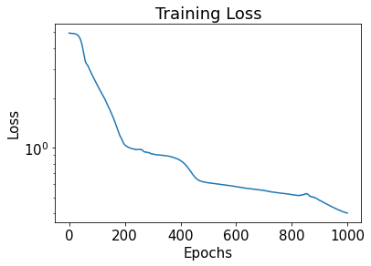

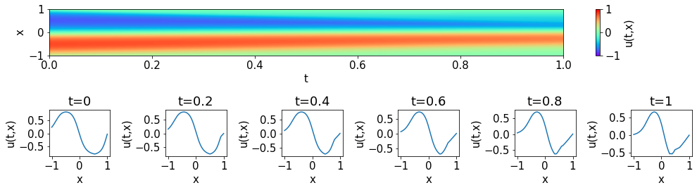

/usr/local/lib/python3.7/dist-packages/numpy/core/_asarray.py:136: VisibleDeprecationWarning: Creating an ndarray from ragged nested sequences (which is a list-or-tuple of lists-or-tuples-or ndarrays with different lengths or shapes) is deprecated. If you meant to do this, you must specify 'dtype=object' when creating the ndarray

return array(a, dtype, copy=False, order=order, subok=True)

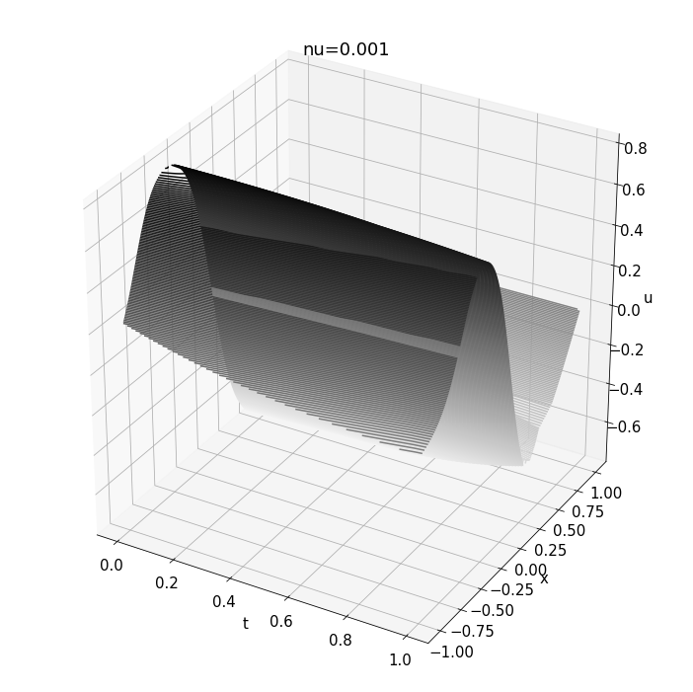

=====================================

Model for nu=0.01

Model: "sequential"

_________________________________________________________________

Layer (type) Output Shape Param #

=================================================================

dense (Dense) (None, 20) 60

dense_1 (Dense) (None, 20) 420

dense_2 (Dense) (None, 20) 420

dense_3 (Dense) (None, 20) 420

dense_4 (Dense) (None, 1) 21

=================================================================

Total params: 1,341

Trainable params: 1,341

Non-trainable params: 0

_________________________________________________________________

Epoch: 1 ; loss: 4.930735

Epoch: 50 ; loss: 3.9273958

Epoch: 100 ; loss: 2.3497388

Epoch: 150 ; loss: 1.4277513

Epoch: 200 ; loss: 0.9302664

Epoch: 250 ; loss: 0.8934682

Epoch: 300 ; loss: 0.8668783

Epoch: 350 ; loss: 0.8260935

Epoch: 400 ; loss: 0.69284475

Epoch: 450 ; loss: 0.5733429

Epoch: 500 ; loss: 0.5575891

Epoch: 550 ; loss: 0.5427774

Epoch: 600 ; loss: 0.52689964

Epoch: 650 ; loss: 0.51325375

Epoch: 700 ; loss: 0.49386522

Epoch: 750 ; loss: 0.47370613

Epoch: 800 ; loss: 0.4524432

Epoch: 850 ; loss: 0.4256126

Epoch: 900 ; loss: 0.3964507

Epoch: 950 ; loss: 0.37183392

Epoch: 1000 ; loss: 0.35523582

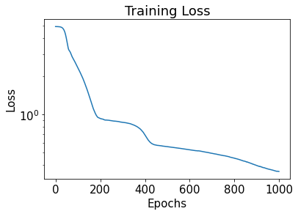

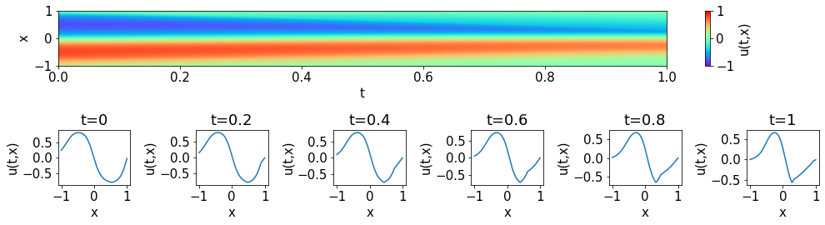

/usr/local/lib/python3.7/dist-packages/numpy/core/_asarray.py:136: VisibleDeprecationWarning: Creating an ndarray from ragged nested sequences (which is a list-or-tuple of lists-or-tuples-or ndarrays with different lengths or shapes) is deprecated. If you meant to do this, you must specify 'dtype=object' when creating the ndarray

return array(a, dtype, copy=False, order=order, subok=True)

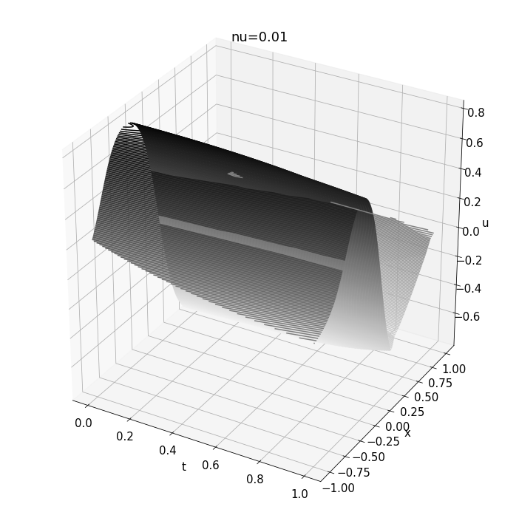

=====================================

Model for nu=0.05

Model: "sequential"

_________________________________________________________________

Layer (type) Output Shape Param #

=================================================================

dense (Dense) (None, 20) 60

dense_1 (Dense) (None, 20) 420

dense_2 (Dense) (None, 20) 420

dense_3 (Dense) (None, 20) 420

dense_4 (Dense) (None, 1) 21

=================================================================

Total params: 1,341

Trainable params: 1,341

Non-trainable params: 0

_________________________________________________________________

Epoch: 1 ; loss: 4.9607067

Epoch: 50 ; loss: 4.117184

Epoch: 100 ; loss: 2.289267

Epoch: 150 ; loss: 1.6363257

Epoch: 200 ; loss: 0.89667374

Epoch: 250 ; loss: 0.7500971

Epoch: 300 ; loss: 0.71552175

Epoch: 350 ; loss: 0.6364465

Epoch: 400 ; loss: 0.47903106

Epoch: 450 ; loss: 0.44054863

Epoch: 500 ; loss: 0.4239094

Epoch: 550 ; loss: 0.41495508

Epoch: 600 ; loss: 0.39287883

Epoch: 650 ; loss: 0.3685439

Epoch: 700 ; loss: 0.3355063

Epoch: 750 ; loss: 0.3102761

Epoch: 800 ; loss: 0.2862444

Epoch: 850 ; loss: 0.23416919

Epoch: 900 ; loss: 0.21088244

Epoch: 950 ; loss: 0.20028551

Epoch: 1000 ; loss: 0.1903201

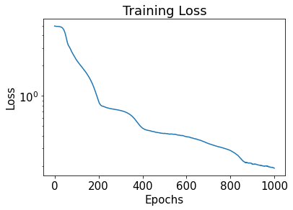

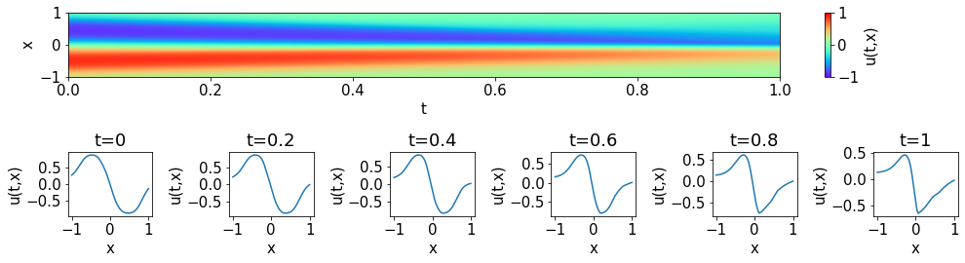

/usr/local/lib/python3.7/dist-packages/numpy/core/_asarray.py:136: VisibleDeprecationWarning: Creating an ndarray from ragged nested sequences (which is a list-or-tuple of lists-or-tuples-or ndarrays with different lengths or shapes) is deprecated. If you meant to do this, you must specify 'dtype=object' when creating the ndarray

return array(a, dtype, copy=False, order=order, subok=True)

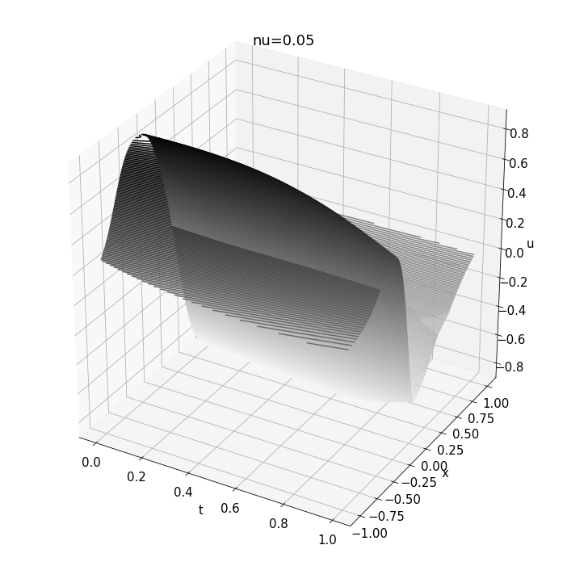

=====================================

Model for nu=0.09

Model: "sequential"

_________________________________________________________________

Layer (type) Output Shape Param #

=================================================================

dense (Dense) (None, 20) 60

dense_1 (Dense) (None, 20) 420

dense_2 (Dense) (None, 20) 420

dense_3 (Dense) (None, 20) 420

dense_4 (Dense) (None, 1) 21

=================================================================

Total params: 1,341

Trainable params: 1,341

Non-trainable params: 0

_________________________________________________________________

Epoch: 1 ; loss: 4.952995

Epoch: 50 ; loss: 4.320343

Epoch: 100 ; loss: 2.665732

Epoch: 150 ; loss: 1.411202

Epoch: 200 ; loss: 0.70734787

Epoch: 250 ; loss: 0.6883949

Epoch: 300 ; loss: 0.67067695

Epoch: 350 ; loss: 0.64746064

Epoch: 400 ; loss: 0.627109

Epoch: 450 ; loss: 0.57221216

Epoch: 500 ; loss: 0.4904956

Epoch: 550 ; loss: 0.4693532

Epoch: 600 ; loss: 0.4598919

Epoch: 650 ; loss: 0.45521724

Epoch: 700 ; loss: 0.44749963

Epoch: 750 ; loss: 0.43636066

Epoch: 800 ; loss: 0.42200258

Epoch: 850 ; loss: 0.4051593

Epoch: 900 ; loss: 0.3883215

Epoch: 950 ; loss: 0.37032557

Epoch: 1000 ; loss: 0.3503912

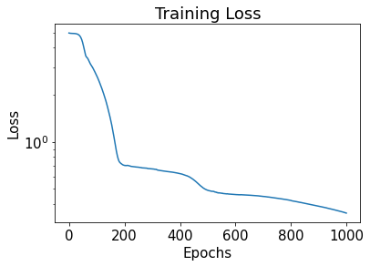

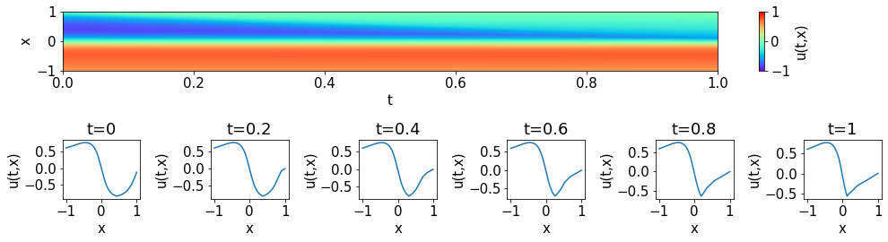

/usr/local/lib/python3.7/dist-packages/numpy/core/_asarray.py:136: VisibleDeprecationWarning: Creating an ndarray from ragged nested sequences (which is a list-or-tuple of lists-or-tuples-or ndarrays with different lengths or shapes) is deprecated. If you meant to do this, you must specify 'dtype=object' when creating the ndarray

return array(a, dtype, copy=False, order=order, subok=True)

